

**Project Report**

| **Only for Course Teacher** | | | | | | |
| --- | --- | --- | --- | --- | --- | --- |
|  | | **Needs Improvement** | **Developing** | **Sufficient** | **Above Average** | **Total Marks** |
| **Allocate Marks & Percentage** | | **25%** | **50%** | **75%** | **100%** | **25** |
| **Problem understanding & Analysis** | **7** |  |  |  |  |  |
| **Implementation** | **8** |  |  |  |  |  |
| **Report Writing** | **10** |  |  |  |  |  |
| **Total obtained marks** | | | | | |  |
| **Comments** |  | | | | | |
|
|

Semester: **Fall 2023**

Student Name: **Md Mubtasim Fuad Khan**

Student ID: **221-35-883**

Batch: **37th** Section: **D2**

Course Code: **SE231** Course Name: **Software Analysis and Design Project**

Course Teacher Name: **Khalid Been Md. Badruzzaman Biplob**

Designation: **Lecturer  
 Department of Software Engineering (SWE)  
 Faculty of Science and Information technology (FSIT)  
 Daffodil International University** Submission Date: **05 May, 2024**

# **Online Super Shop Project Sequence Diagram**

## **Sequence Diagram-1: User Registration and Login**

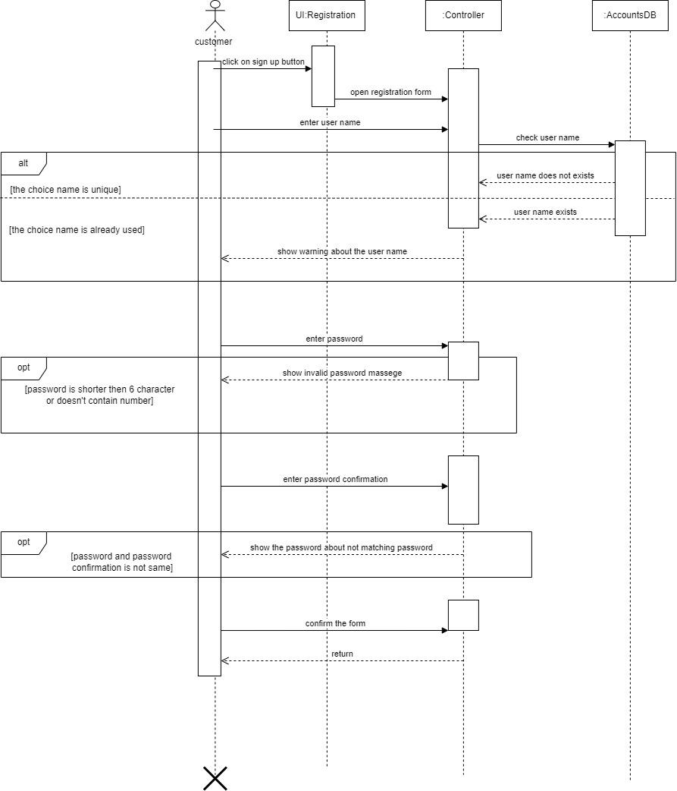

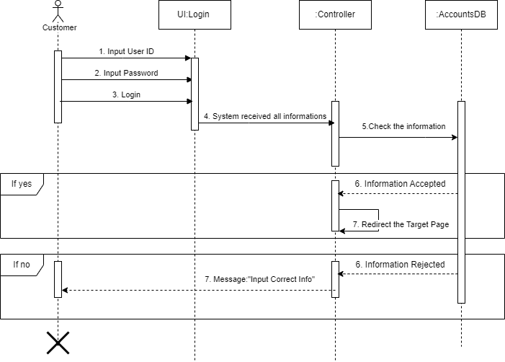

## **Sequence Diagram-2: View Product**

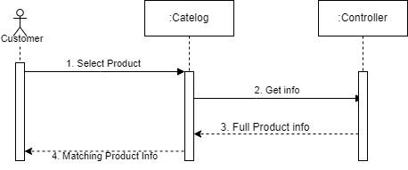

## **Sequence Diagram-3: Shopping Cart**

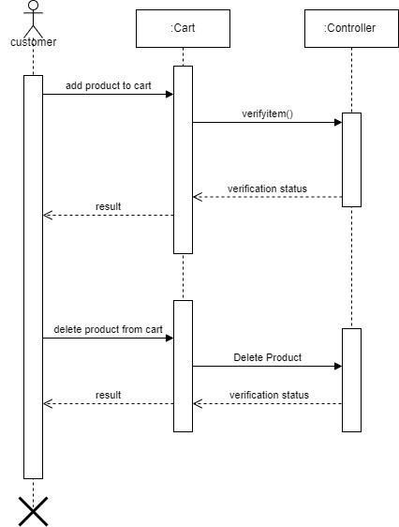

## **Sequence Diagram-4: Product Management**

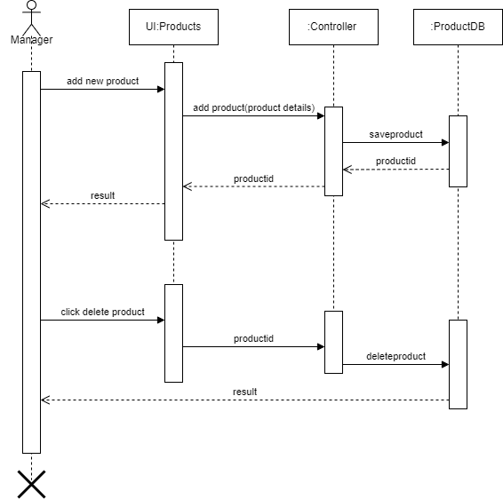

## **Sequence Diagram-5: Search Product**

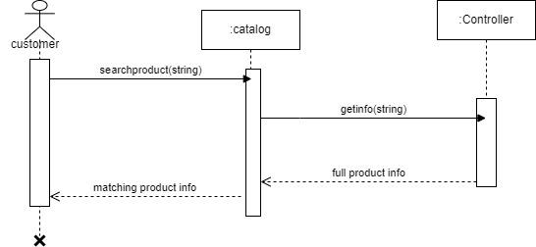

## **Sequence Diagram-6: Order Placement**

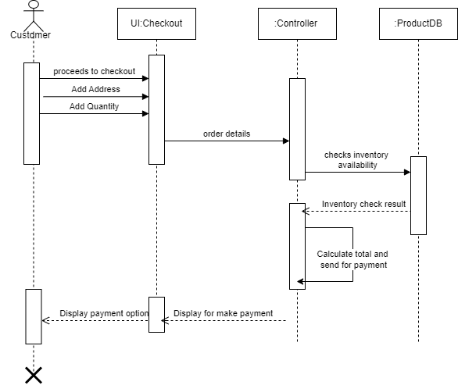

## **Sequence Diagram-7: Payment Integration**

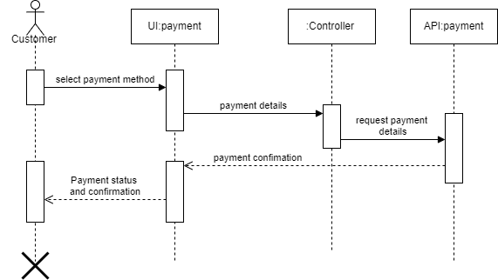

## **Sequence Diagram-8: Product Reviews and Ratings**

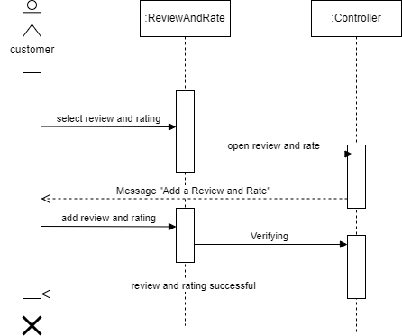

## **Sequence Diagram-9: Order Cancellation**

## **Sequence Diagram-10: Delivery Tracking**

